School of Computer Science and Artificial Intelligence

Lab Assignment # 3.1

Program : B. Tech (CSE)
Specialization : AIML
Course Title : AI Assisted Coding Course Code : 23CS002PC304
Semester : VI
Academic Session : 2025-2026
Name of Student : P. Sricharan goud
Enrollment No. : 2303A52100
Batch No. : 33
Date : 13/01/26

Title

Experiment on Prompt Engineering Techniques for Python Program Generation Using AI-Assisted Tools

Lab Objectives

- To understand and apply different prompt engineering techniques for generating Python programs using AI-assisted tools.
- To analyze the impact of context, constraints, and examples on the accuracy and efficiency of AI-generated code.
- To develop and refine real-world Python applications through iterative prompt improvement and testing.

Lab Outcomes

- Students will be able to design effective prompts to generate correct and optimized Python code.
- Students will be able to compare and evaluate AI-generated solutions produced using different prompting strategies.
- Students will be able to implement, test, and document real-world Python applications using AI-assisted coding tools.

Tools Used

- AI-assisted coding tool (ChatGPT)
- Python 3.x
- Standard Python IDE / Interpreter

Experiment 1: Zero-Shot Prompting – Palindrome Number

Prompt Type: Zero-Shot
Objective: Check whether a number is a palindrome.

Observations
- AI generated correct logic for positive integers.
- Failed to explicitly handle negative numbers.
- Required manual refinement for edge cases.

CODE:
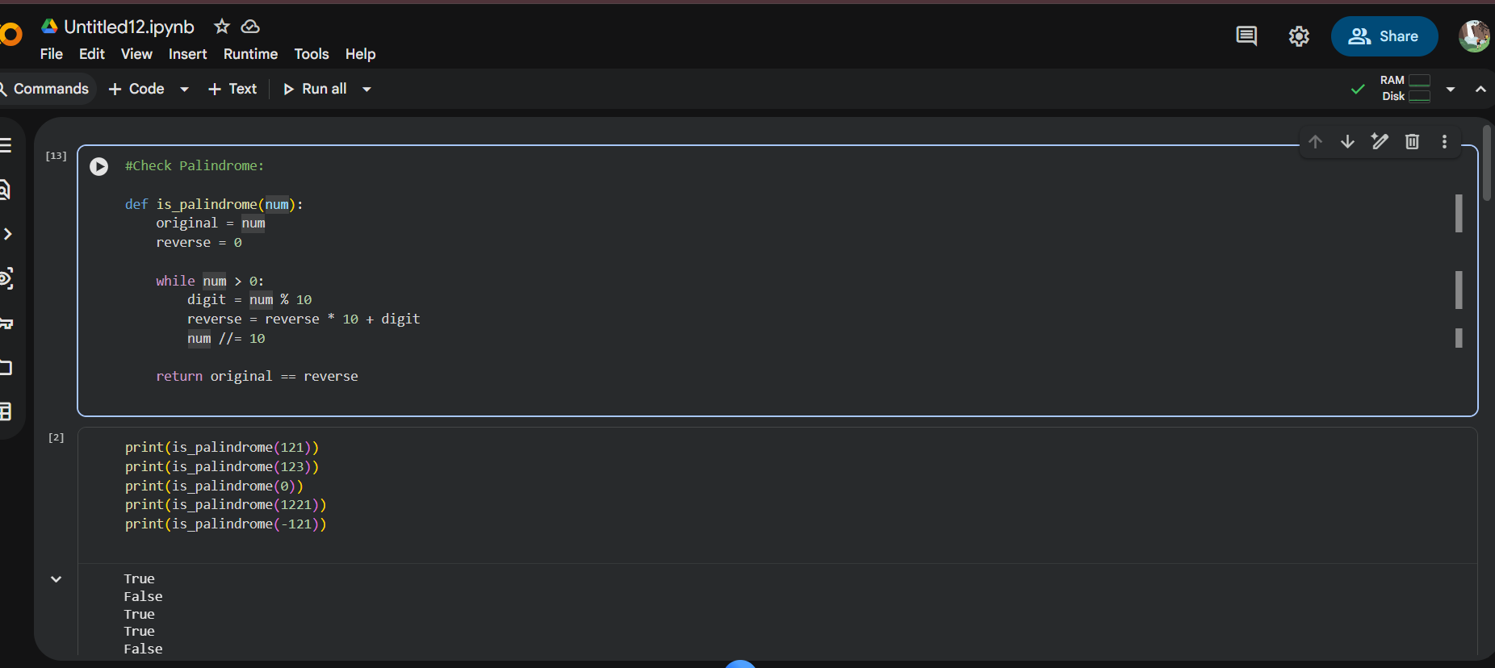

Experiment 2: One-Shot Prompting – Factorial Calculation

Prompt Type: One-Shot
Example Given: Input: 5 → Output: 120

Observations
- Code clarity improved compared to zero-shot.
- Handled 0! correctly.
- Included basic validation for negative numbers.

CODE:

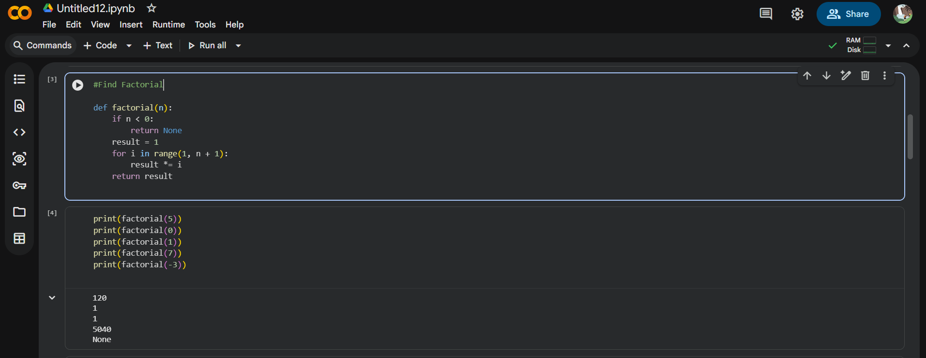

Experiment 3: Few-Shot Prompting – Armstrong Number Check

Prompt Type: Few-Shot
Examples Provided:
- 153 → Armstrong Number
- 370 → Armstrong Number
- 123 → Not an Armstrong Number

Observations
- Correct mathematical logic inferred.
- Output format matched examples exactly.
- Input validation required additional refinement.

CODE:

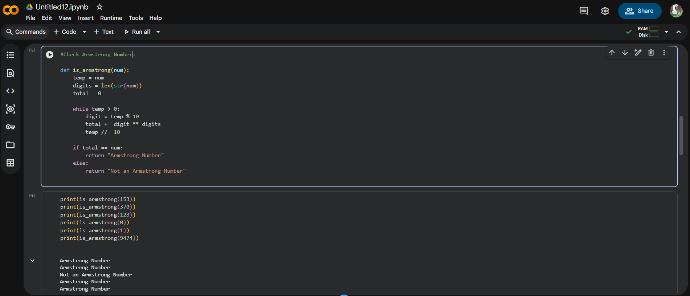

Experiment 4: Context-Managed Prompting – Number Classification

Prompt Type: Context-Managed
Task: Classify a number as Prime, Composite, or Neither.

Observations
- Efficient √n optimization applied.
- Proper handling of 0, 1, and invalid inputs.
- Most robust and production-ready solution.

CODE:
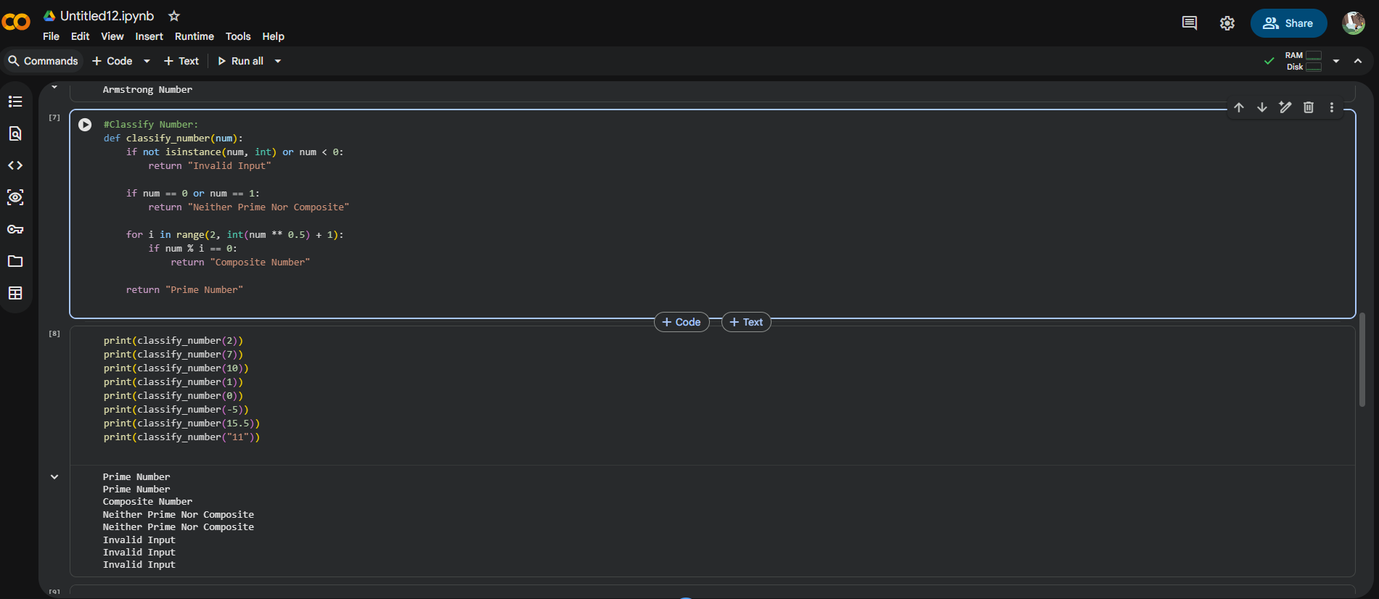

Experiment 5: Zero-Shot Prompting – Perfect Number Check

Prompt Type: Zero-Shot

Observations
- Basic logic generated correctly.
- Logical error for input 0.
- Inefficient O(n) loop required optimization.

CODE:

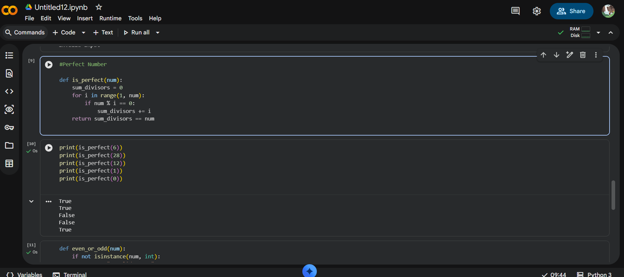

Experiment 6: Few-Shot Prompting – Even or Odd with Validation

Prompt Type: Few-Shot
Examples Provided:
- 8 → Even
- 15 → Odd
- 0 → Even

Observations
- Proper input validation inferred.
- Clear and consistent output.
- Negative numbers handled correctly.

CODE:

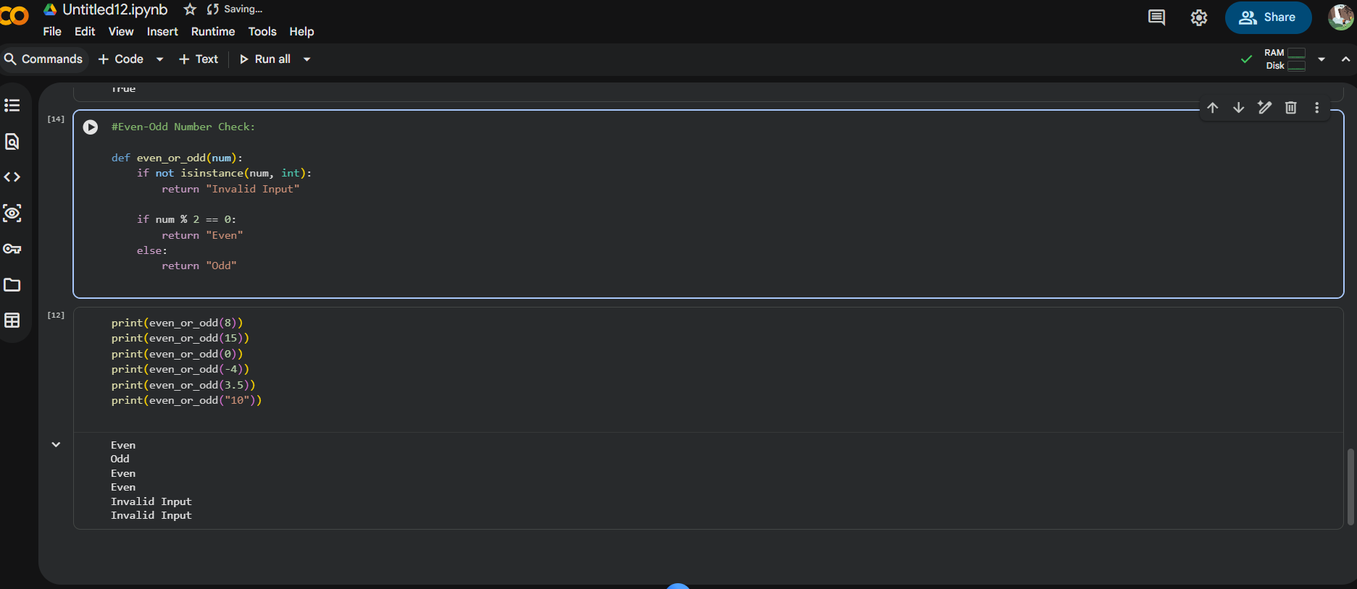

Comparative Analysis

Prompting Technique | Accuracy | Validation | Efficiency | Clarity
Zero-Shot | Medium | Low | Low | Average
One-Shot | Good | Medium | Medium | Good
Few-Shot | High | High | Medium | Very Good
Context-Managed | Very High | Very High | High | Excellent

Result
- The quality of AI-generated Python code improves significantly with better prompt design.
- Few-shot and context-managed prompting produced more accurate, optimized, and reliable programs.
- Zero-shot prompting is suitable only for simple tasks and requires manual verification.

Conclusion:

This lab successfully demonstrated the effectiveness of various prompt engineering techniques in generating Python programs using AI-assisted tools. As the level of guidance in prompts increased—from zero-shot to context-managed—the accuracy, efficiency, and robustness of the generated code also improved. Proper prompt design plays a critical role in producing reliable AI-generated software solutions.

Future Scope:

- Applying prompt engineering techniques to larger real-world applications such as web development and data analysis.
- Exploring advanced prompting methods like chain-of-thought and self-consistency prompting.
- Integrating AI-assisted coding tools into software engineering workflows for improved productivity.

